Basic Structure

Look at the chart below, what is happening?

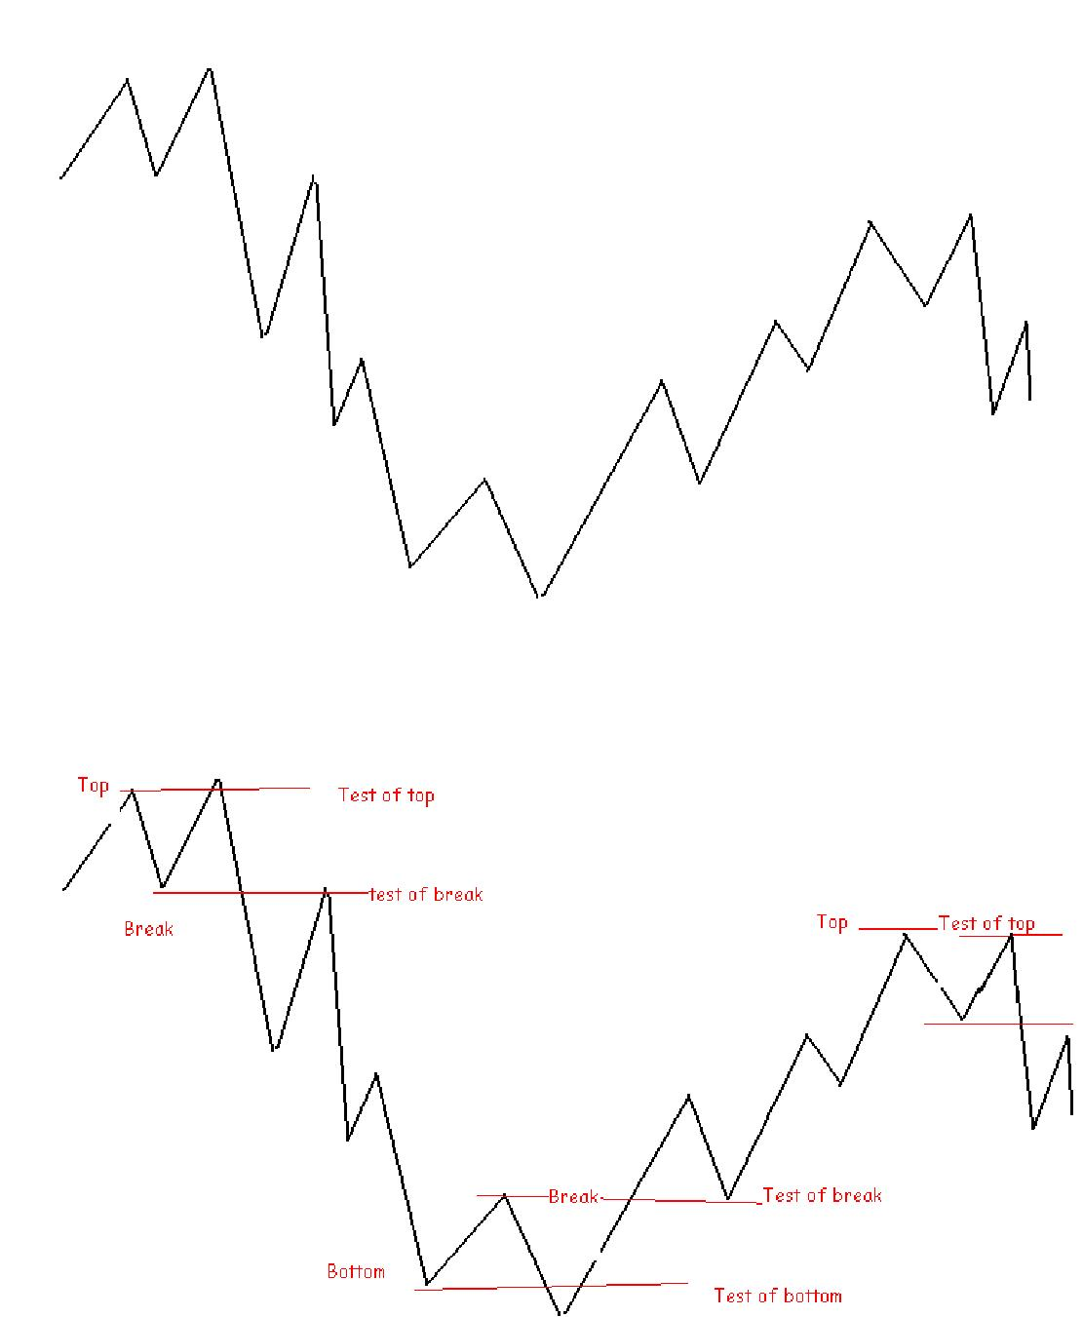

This is the basic structure of the market. Market will do this again and again in all time frames. But the price action will unfold differently each time.

Inside and Outside Days

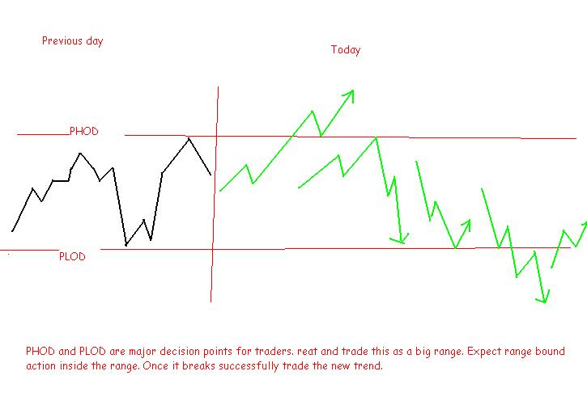

When price trades within yesterdays range it is an inside day. It shows nothing has changed since yesterday and market is likely to trade within the band...Previous day’s price band acts as a big range. So trade this as you trade a range. Selling the highs and buying the lows.

If the market is trading above PDH or below PDL it is an outside day. If it is above PDH bias is bullish and below PDL bias is bearish .An outside day shows us that something has changed since yesterday.

Inside the range, buy at support when price falls, and sell at resistance when price rises.

If price trades above the PDH the buyers are clearly in control and buy pullbacks

If price breaks below the PDL the sellers are control and sell retracements.

Trends and Ranges

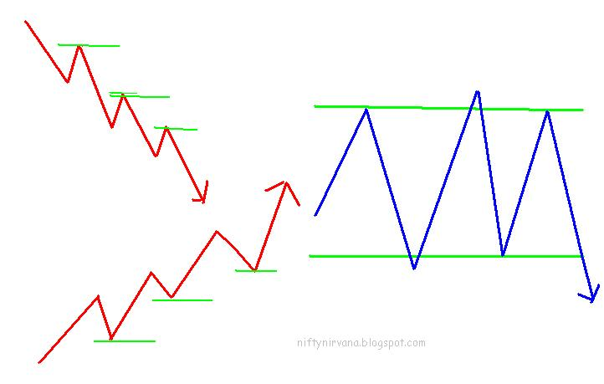

*Trade the pullbacks in trends. In trading ranges trade the Breakout failures*

*Trend is a series of Breakouts and trading ranges are a series of Breakout failures*

Layer Over Layer

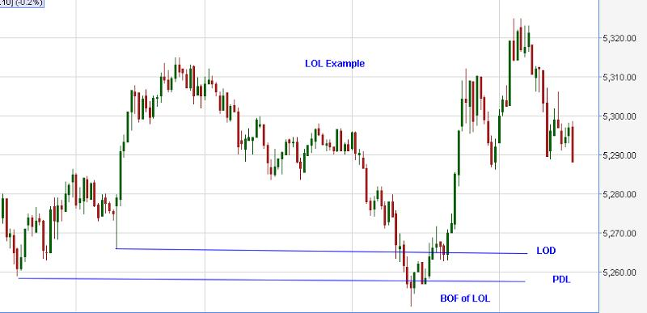

Here LOL means Layer Over Layer. I use this to denote two or more important Support or Resistance levels positioned very close. A lot of traders will get trapped in these areas. Usually the price will break the first level and the break of second level will fail.

Trapped breakout traders of these levels will panic and start to exit initiating a move in the opposite direction. Then momentum traders join them and fuel the move further.30 to 50 point moves are very common from LOL areas.

**Watch "LOL" and laugh all the way to the bank**

Three Trade Setups

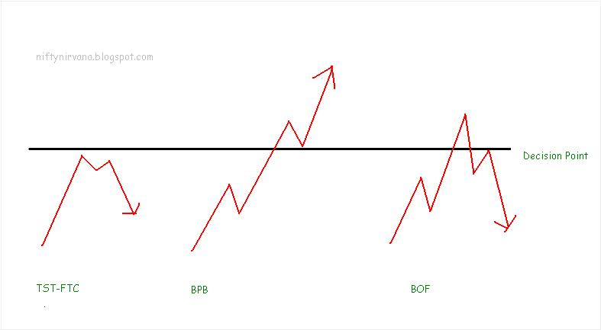

My trading revolves around trader decision points. I trade the acceptance and rejection of price at these areas and always trade away from the decision points.

Decision points are price levels where the market strongly reacted earlier. Most of the time they are proven price levels. But market will always create new DP levels Traders are creatures of habit and you can expect them to react at these price levels again

There are three trade setups when price encounters a decision point.

1. Price stalls just before the DP and there is no attempt to break the level. In other words it is failure to breakout. I call this TST and FTC (There is a slight difference between the two). After a TST and FTC price drifts down to the lower DP
2. Price breaks the level and pulls back. Pull back find support at the breakout level and the new level holds. This is a signal to trade with the trend. If the level holds price can only do one thing that is to go to the next DP. This setup is called BPB
3. Price breaks above the DP but fail to hold the level. There is strong opposing order flow on the other side and price get rejected.. Naturally it has to come down to a lower DP where new buying emerges, this is called a BOF.

*These are the three setups you can trade with the lowest risk.*

**Trading the Ranges**

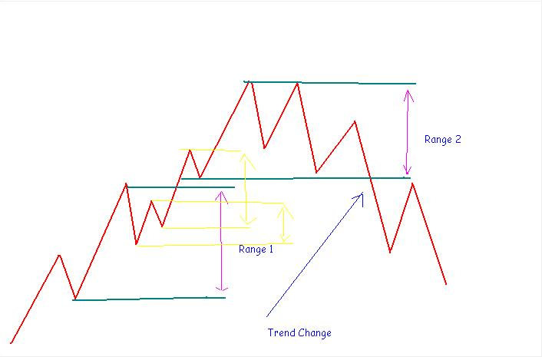

Theoretically 70% of the time markets will be trading in a range. They are in a trend only at the remaining 30% of the time. It is very difficult to know exactly where the trend will start and where it is going to end. By the time we know a trend has started it is too late to enter and we are not able to capture a major portion of it.

So I thought it is better to trade the markets as if it is in a range 100 % of the time. Then I am going to be correct 70 % of the time. I assume the market is in a range all the time and for me a trend is a breakout of a range extreme. A prolonged trend is a series of range breakouts whereas the range is a series of range breakout failures.

Every range extreme is not tradable in my scheme of things. I would like the range extreme to match with trader decision points, in other words a confluence. A slight change in perspective can make a lot of difference. Many people struggle with the concept of trend in multiple time frames and get whip sawed left and right.

Buy Low, Sell High

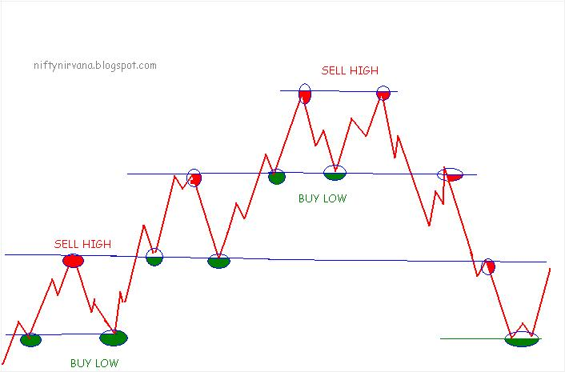

Money is made by buying low and selling high. It is a universal truth. Trading cannot be different.

The problem is many traders do not know where exactly the lows and the highs are. You need a slight change in perspective to know this.

Markets move in short term ranges. A trend is a series of range breakouts. When the Markets break to new highs, it is always in the lower end of the range above. Once you become comfortable with this reality, you can always trade whether it is trending or ranging.

If you are not comfortable trading counter trend, *stay with the trend. If the current price range is above the previous one, the trend is up*, and try to buy the range low. If we are in a lower price range only attempt to sell the range highs

Many "Gurus" advise to trade trends and stay out when markets range. I do not subscribe to this view.

***Learn to trade sideways markets so that you can trade all the markets***

Barbed Wire

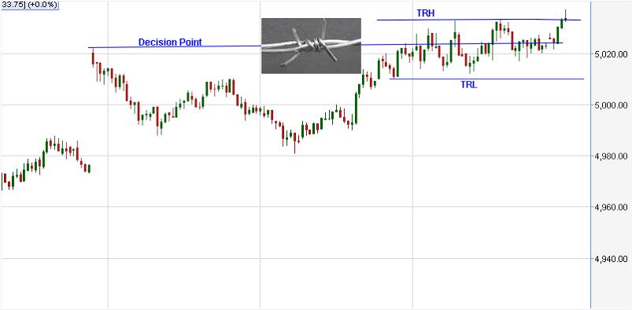

Normally price will not stay at the decision points much longer. Decision points are areas from where price moved away historically. These points are proven levels of demand supply imbalance. I expect a significant group of traders to react and act at these levels and create an imbalance again.

On rare occasions price will not run away from these areas, Instead it chops around it creating a tight trading range (TTR)..This is a very dangerous pattern which I call “Barbed Wire". If you try to trade the DP, you may get whipsawed left and right. Fortunately this pattern is rare and most of the time it appears around BRN. Once a BOF trade fails don't be in a hurry to enter again. Better to stay out till price moves out of the TTR. Never attempt Counter Trend trades.

*When in doubt, stay out*

Trends

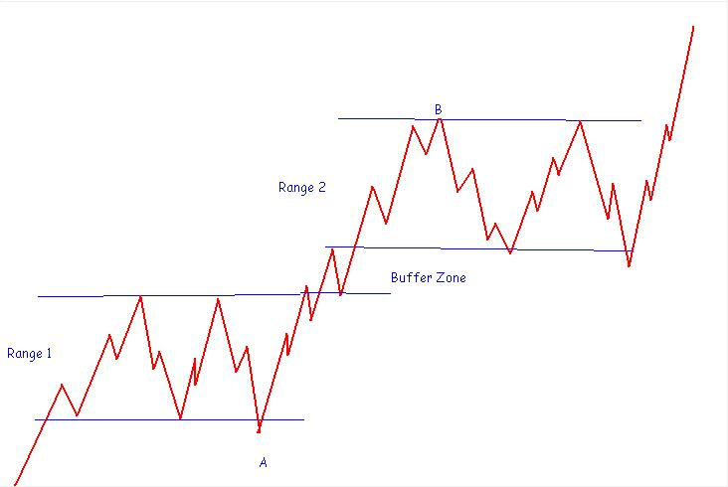

“Trade the Trend"., "Trend is your Friend". Every trader might have read it a thousand times. But unfortunately nobody knows what a trend is, where a trend starts and where it ends. Many traders think a trend starts when price breaks out of a range. Wrong. They are going to miss most of the trend move

Trend is nothing but a prolonged movement of price in a particular direction. If you approach the market as if it is ranging all the time, there is no confusion. Almost always a trend starts at a range extreme and terminates at the extreme of another probable range. In the above example you are entering at the BOF of a range extreme marked A. You expect the price to break out above the other extreme and move up to a higher trading range high marked B. This approach will help you to capture a major portion of the trend move (from A to B) and you are doing it with the lowest risk. So love the extremes.

Price Channels

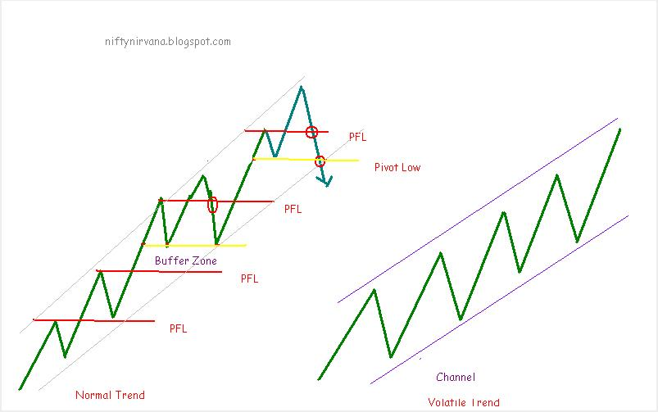

Real breakthrough in my trading came when I started trading the Market as if it is in a range all the time. I consider the trend as a series of range breakouts.  [(Read](http://niftynirvana.blogspot.in/2012/05/trading-ranges.html)). I try to buy the lows and sell the highs  [(Read](http://niftynirvana.blogspot.in/2012/05/buy-low-sell-high.html)). But there are situations where we cannot trade a trend with this approach. This is when the price is in a Channel.

A Channel is a very difficult pattern to trade. It is like a diagonal  [Barbed Wire.](http://niftynirvana.blogspot.in/2012/06/barbed-wire.html) In fact Channels are nothing but trends. Most of the traders do not correctly distinguish between a trend and a channel. I will try to explain.

Look at the above picture. You can see two types of trends. Both look like channels. You need to look closer to know the difference. First one is a normal trend and second one a volatile trend which we call a Channel.

Markets move in swings. A swing high is a minor resistance and once broken it may act as support. There is an imaginary line above each swing high which I call Price Flip Line ( PFL) In a normal trend generally price respects PFL .Sometimes pull backs in a trend reverses before testing a PFL creating a buffer zone. A Buffer Zone indicates the trend is strong. Once the price breaks the low of the swing that made the highest high, we can safely assume the trend has reversed..

A Channel is volatile trend where price will not respect the PFL. Pullbacks will reverse somewhere between PFL and Pivot Low. Be very careful while trading dynamic DPs such as HOD and LOD. Ensure that you are not in a volatile trend which is called a Channel.

If you are in a trade and riding a trend never exit before the PFL cracks and never stay in a trade after the Pivot low cracks. I have shown the long example only, but this is applicable in short side also.

Initial Stops

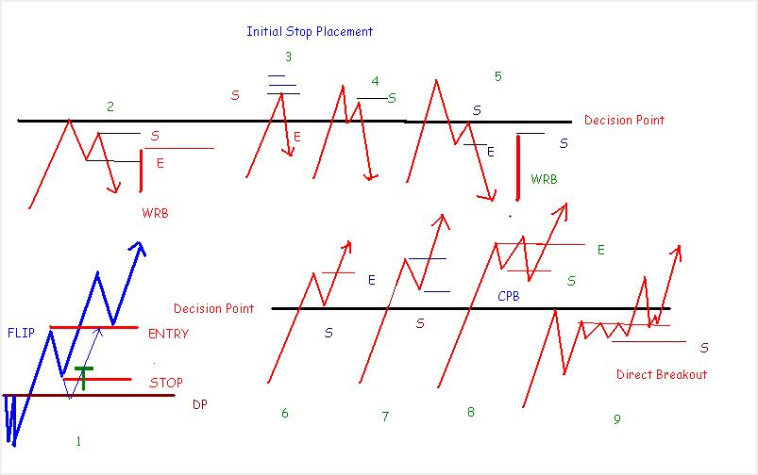

Initial stop placement is always a problem area for traders, especially if you are a single lot BPL trader like me. Many times Market will take away our stop before going in our direction. Nothing is more frustrating than this. We can’t help. It is all in the game. How can we place more effective stops? Let me share some thoughts.

I always trade away from DP so that I can hide my initial stop behind a DP. But it may not be possible always due to RR considerations. So we have to think about alternatives. We will have a look at some scenarios

Look at Pic 1. Price breaks a DP and pullback forming a swing high. Now there are three ways to enter into this pullback.1.At DP on pull back with stop below DP 2.Entry on a formation say a pin bar with a stop below it. 3. On break of swing high with a stop below the pull back low. Mostly I go for the third type. I expect this broken swing high to act as Flip and give support on the way down. If the swing low is very far I scratch on break of the Flip. If RR permits ideal stop is always below the DP

Pic.2. deals with a TST. Ideal stop is above DP only. But I wait for a swing low formation and short below it to have two layers of defense, a Flip and a swing point. Stop can be placed above second push swing high if DP is too far. If the bar which triggered the entry is a WRB we can place the stop above this bar also.

Pics 3,4,5, refers to a BOF. For a BOF the best stop is always above the extreme. There is no point in keeping stops much above the extreme because once price moves above the extremes, stops will start triggering and price may move up causing more loss to you. As per the situation keep stop losses above DP, swing High or WRB high.

Pics 6,7 &8 relates to a BPB. As you know the ideal stop is below the DP. Alternatively it could be below a swing low. But there is always a danger of a complex pull back happening. Only way to avoid it is to have stop below the DP or exit the trade on break of the Flip as a scratch.

Pic . 9. While trading a direct breakout always be well aware of this trap. Price attempts to break a range high many times creating a lot of stops above this area. Before the breakout , price consolidates just below the range high forming another narrow range high. After the breakout price will pull back to this consolidation high breaking the range high to the down side. We will think it as a BOF and exit. Others will short the BOF. Price will reverse from the consolidation high with a vengeance trapping the majority.

There are no hard and fast rules for price action trading. Price action will unfold in million ways. The ability to think and adapt to the changing market conditions is very critical in trading.